**Remarks**

**Assignment**

|  |  |
| --- | --- |
| Subject Name | **:** Network administration & Services |
| Subject Code | **:** 66672 |
| Expt. / Job No | **:** 03 |
| Name of the Expt. / Job | **:** Perform the design, develop and simulation of Static  Routing. |
| Date of the Expt. / Job | **:** 17-05-2023 |
| Date of the Sub. / Job | **:** 22-05-2023 |

|  |  |  |  |
| --- | --- | --- | --- |
| **Submitted By:** | | **Submitted To:** | |
| Name | : Md. Jahid Hossain | Name | : Md. Abbas Uddin |
| Department | : Computer | D.P Head | **:** Computer |
| Board Roll | : 434575 |  |  |
| Semester | : 7th |  |  |
| Session | : 2019-2020 |  |  |

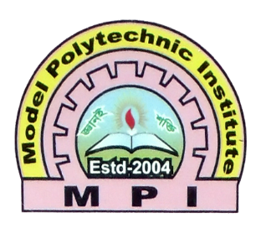

**MODEL POLYTECHNIC INSTITUTE, JASHORE**